DNA Policy - Acting as a Fiscal Agent 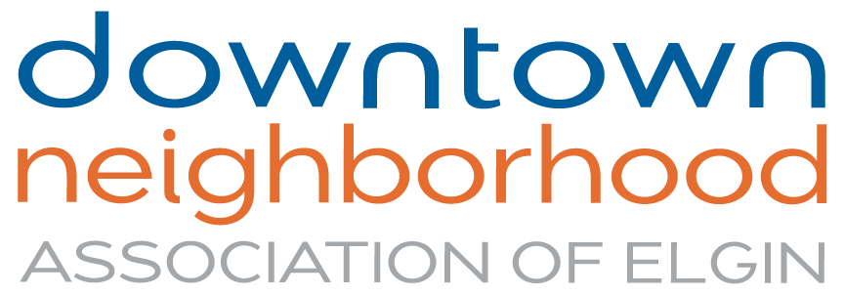

The Downtown Neighborhood Association of Elgin (DNA) has adopted the following Policy effective August 21, 2023.

The Downtown Neighborhood Association of Elgin, “DNA,” will consider requests by local persons or groups for DNA to act as a fiscal agent for the receipt and pass-through of grant funds.

The DNA Board of Directors will consider the following factors in making the decision as to act as a fiscal agent:

- The size of the grant;
- The capability of the grantee to fulfill the requirements and conditions of the grant;
- The grantee’s mission and the grant’s purpose, and whether they align with the mission and current priorities of DNA;
- The availability of DNA staff to administer the grant;
- The nature of the funding entity, and whether DNA has, or would be, requesting funds for its own activities from that same entity.

DNA will pass through to the grantee only those monies received by DNA from the funding entity, and under no circumstances will be responsible for any monies withheld, for any reason, by the funding entity.

DNA will retain a percentage of the total grant to cover the costs of administering the pass-through of funds and other accounting tasks required by the grant, and those required by state and federal law. This percentage will be determined by the DNA Board when accessing the grant opportunity and scope of work.

Requests in writing should be submitted to the DNA Executive Director at least three weeks prior to a board meeting in which the fiscal agency request will be considered.

SAMPLE FISCAL AGENT AGREEMENT

The Downtown Neighborhood Association of Elgin “DNA”, agrees to serve as fiscal agent for {ORGANIZATION} under the following stipulations:

- The fiscal agent status is for one project grant only.

- {ORGANIZATION} is responsible for submitting the complete grant and final report and for providing copies of these to DNA for record-keeping purposes.

- {ORGANIZATION} will keep the DNA Executive Director informed about the progress of the project and any deviations from the grant will be brought to the attention of the DNA.

- {ORGANIZATION} will not write any contracts or accept contributions from other sources.

- DNA will keep all grant funds in its account and will write checks when provided appropriate bills or proof of expenses by {ORGANIZATION}.

- Any unused funds, profit, or interest will be spent as stipulated by mutual agreement before any checks are issued for the grant.

- The DNA Executive Director, serving as authorized agent, has signed below, and the Board of Directors is aware of this agreement.

Grantee
Signature of Project Director: _______________________________ Date: __________
_______________________________
Print Name and Title
Fiscal Agent
Fiscal Agent Organization: Downtown Neighborhood Association of Elgin
Signature of Fiscal Agent: _______________________________ Date: __________

_______________________________
Print Name and Title

